# Phase 3 Enterprise Dynamics challenge

For phase 3 of your TRiP with Enterprise Dynamics the following challenge was created.

## Assignment 1

For the first assignment you are going to create a base model to work from. In the image below you can find a factory line containing multiple (different) machines. Copy this factory line into an Enterprise Dynamics model. Each station should only be connected to their closest neighboring station. Except for “De-paneling robot” and “Pin stitcher”, they should both be connected to “Assembly stage 1” where they will be combined into 1 product. “Start scanner” and “Board programming” will be the first machines after the “source(s)”. Do not forget to add a “Sink” after “Packaging and connector inspection.

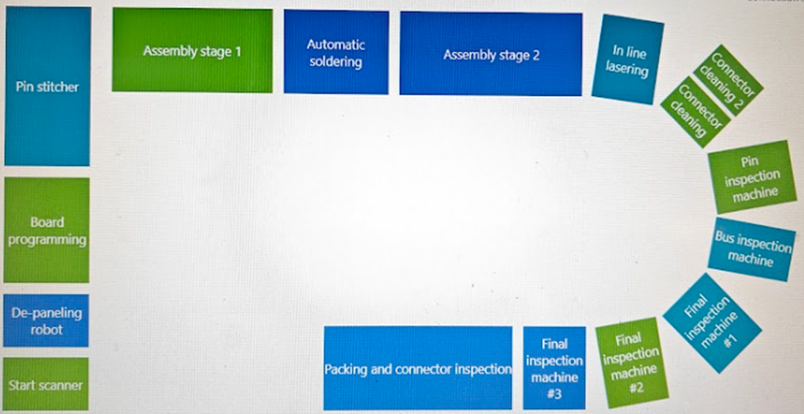

Figure 1 Production line overview

## Assignment 2

Now that the base is created more information can be added. The first piece of information will be the service time of each machine. In appendix A is a time table which contains the service times of each step an operator could take within the production line.

## Assignment 3

Change the model so that it is able to continuously produce products. Aim for a minimum of 10 products.

## Assignment 4

Create a copy of the previous model.

Search the dataset to find equivalent data to the data in the table and change the current parameters to those in the dataset.

The original can be used to benchmark the results of the new model. Find the differences between the output and find the bottleneck within the current production line.

## Assignment 5

If not done already, use the distribution from the dataset to simulate how a real production line functions.

Again, find the differences between the output and find the bottleneck within the current production line. Do this for (at least) 5 runs.

# Appendix A – Time table

Table 2 Time table

|  |  |  |  |  |
| --- | --- | --- | --- | --- |
| Step | Task | Time it took | Timestap | Operator |
| 1 | Grabs a circuit board | 1,56 | 1,56 | Operator 1 |
| 2 | Puts the circuit board in the depaneling machine and turns it on | 2,82 | 4,38 | Operator 1 |
| 3 | The depaneling machine is done | 2:07,04 | 2:11,42 | None |
| 4 | The pin stitcher machine is turned on | 2:23,89 | 4:35,31 | Operator 1 |
| 5 | The circuit board gets taken out of the depaneling machine | 47,75 | 5:23,06 | Operator 1 |
| 6 | The casing gets taken out of the pin stitcher and added together with the circuit board at assembly stage 1 | 24,93 | 5:47,99 | Operator 1 |
| 7 | The board gets put in the soldering machine | 1,58 | 5:49,57 | Operator 1 |
| 8 | The board gets taken out of the soldering machine | 57,69 | 6:47,26 | Operator 1 |
| 9 | The board gets put in a basket before assembly stage 2 | 10,40 | 6:57,66 | Operator 1 |
| 10 | Start the assembly at stage 2 using the beamer | 26,07 | 7:23,73 | Operator 1 |
| 11 | Assembly at stage 2 is done and awaiting movement to the laser | 17,18 | 7:40,91 | None |
| 12 | The board gets put in the laser | 34,27 | 8:15,18 | Operator 1 |
| 13 | The laser is done and waiting for operator pickup to cleaning | 1:23,00 | 9:38,18 | None |
| 14 | The board gets put in the cleaning for stage 1 | 20,64 | 9:58,82 | Operator 2 |
| 15 | The board gets turned around for cleaning stage 2 | 14,53 | 10:13,35 | Operator 2 |
| 16 | The board gets put into the pin inspection | 55,62 | 11:08,97 | Operator 2 |
| 17 | The board gets put into the BUS checker | 40,33 | 11:49,30 | Operator 2 |
| 18 | The board gets put into the final checker and the light turns red | 1:23,88 | 13:13,18 | Operator 2 |
| 19 | The light turns green and the machine moves the board so it can be picked up | 5,10 | 13:18,28 | None |
| 20 | The board gets picked up and put in the basket at assembly line 3 | 38,55 | 13,56,83 | Operator 2 |
| 21 | The board gets put on a manual pin checking machine | 18,66 | 14:15,49 | Operator 2 |
| 22 | The board gets checked | 1,68 | 14:17,17 | Operator 2 |
| 23 | The board gets packaged into a plastic bag | 44,00 | 15:01,17 | Operator 2 |
| 24 | The box is folded | 7,15 | 15:08,32 | Operator 2 |
| 25 | The packaged board gets put into the box | 2,43 | 15:10,75 | Operator 2 |
| 26 | The packaged board gets closed and wait for movement to the blue bin | 30,69 | 15:41,44 | Operator 2 |